MySql….

To create database

create database university;

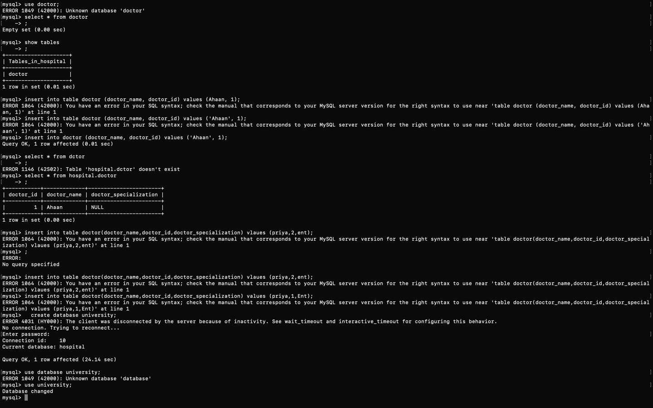

To create table in university database;



To see the table(rows and column);



Add column to table





To change datatype

Example change of collage id from int to varchar;



Change of any column name :

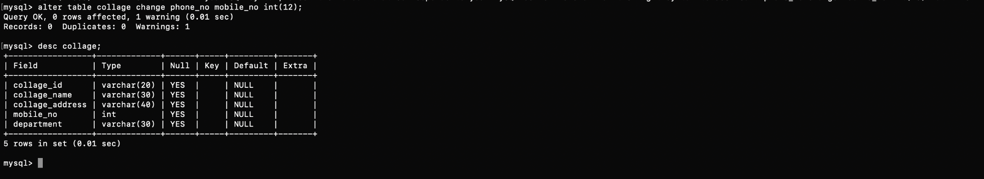

Rename table from collage to school

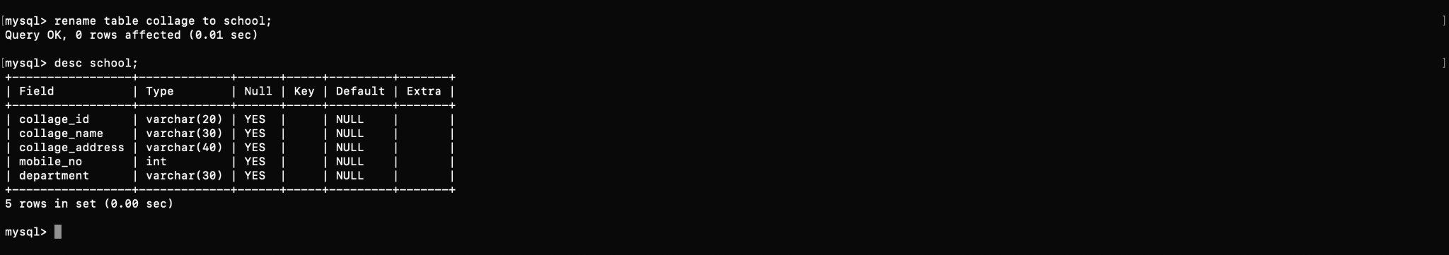

Drop any column name;



Insert command

ysql>

mysql> insert into collage values('23','srm','35 west rd chennai','4563429872','etce');

ERROR 1264 (22003): Out of range value for column 'mobile_no' at row 1

mysql> insert into collage values('23','srm',35 west rd chennai','456342982','etce');

'> ^C

mysql> insert into collage values('23','srm','35 west rd chennai','456342982','etce');

Query OK, 1 row affected (0.00 sec)

mysql> insert into collage values('23','stmm','65 east rd chennai','4563428972','eee');

ERROR 1264 (22003): Out of range value for column 'mobile_no' at row 1

mysql> insert into collage values('23','stmm','65 east rd chennai','45634872','eee');

Query OK, 1 row affected (0.00 sec)

mysql> desc collage;

+-----------------+-------------+------+-----+---------+-------+

| Field | Type | Null | Key | Default | Extra |

+-----------------+-------------+------+-----+---------+-------+

| collage_id | varchar(20) | YES | | NULL | |

| collage_name | varchar(30) | YES | | NULL | |

| collage_address | varchar(40) | YES | | NULL | |

| mobile_no | int | YES | | NULL | |

| department | varchar(30) | YES | | NULL | |

+-----------------+-------------+------+-----+---------+-------+

5 rows in set (0.00 sec)

Select command

mysql> select * from collage;

+------------+--------------+--------------------+-----------+------------+

| collage_id | collage_name | collage_address | mobile_no | department |

+------------+--------------+--------------------+-----------+------------+

| 23 | srm | 35 west rd chennai | 456342982 | etce |

| 23 | stmm | 65 east rd chennai | 45634872 | eee |

+------------+--------------+--------------------+-----------+------------+

2 rows in set (0.00 sec)

Update command ;

mysql> select * from collage;

+------------+--------------+--------------------+-----------+------------+

| collage_id | collage_name | collage_address | mobile_no | department |

+------------+--------------+--------------------+-----------+------------+

| 23 | srm | 35 west rd chennai | 456342982 | etce |

| 23 | stmm | 65 east rd chennai | 45634872 | eee |

+------------+--------------+--------------------+-----------+------------+

2 rows in set (0.00 sec)

mysql> update set collage_id='34' where collage_name=stmm;

ERROR 1064 (42000): You have an error in your SQL syntax; check the manual that corresponds to your MySQL server version for the right syntax to use near 'set collage_id='34' where collage_name=stmm' at line 1

mysql> update collage set collage_id='24' where collage_name='stmm';

Query OK, 1 row affected (0.00 sec)

Rows matched: 1 Changed: 1 Warnings: 0

mysql> select * from collage where collage_id=24;

+------------+--------------+--------------------+-----------+------------+

| collage_id | collage_name | collage_address | mobile_no | department |

+------------+--------------+--------------------+-----------+------------+

| 24 | stmm | 65 east rd chennai | 45634872 | eee |

+------------+--------------+--------------------+-----------+------------+

1 row in set (0.00 sec)